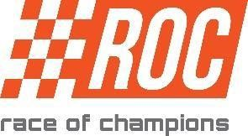
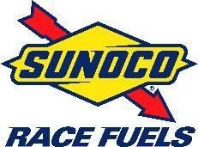
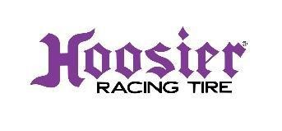
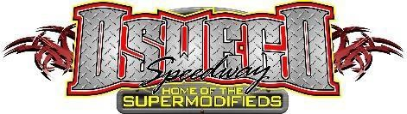
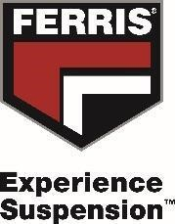
66th Annual “Race of Champions 250” Oswego Speedway, September 17th, 2016
“Race of Champions 250” Lap Sponsorship Form 2016

Presented by
1074 Sulphur Springs Rd.
Owego, NY 13827
607-687-2991 cell:607-759-7881 bjspald@msn.com
Contact: Betty Sherwood www.SpaldingFoundation.org

Keep the tradition Alive!!!
Be a proud sponsor for one lap or more at a minimum of $50.00 per lap.
All lap money will be paid to Positions 1-15, thru “Luck of the Draw”, for all laps sponsored!
**************************************************************************************************
To sponsor a lap/laps for this prestigious event, please print the form below and mail to the Spalding Foundation for Injured

Drivers, Inc., or contact the foundation at 607-687-2991 / cell 607-759-7881/email bjspald@msn.com

Sponsor Name:____________________________________________________________________________

Addres:____________________________________________________________________________

City:____________________State:________________Zip:__________________ Phone: _________________

Choose your lap number based on availability.

Lap # (1st choice)______(2nd choice)______(3rd choice)_______(4th choice)______ No choice______

Lap Sponsor Message:_________________________________________________________________ (i.e.) “Good luck to ?
“ “In Memory of ?” “Smith Motorsports” “Business name” Or your own special message.
Acceptable Payment Methods(1) Cash (2) Check Payable to: Spalding Foundation for Injured Drivers, Inc.
(Please place “ROC lap sponsor” in your check memo line.”

(3) Credit Card/information
Name:___________________________________________________
CC#:_____________________________________Exp date:_______________Security Code:_________

